TRIM is an electronic document and records management system used by the University as its central corporate record keeping system for vital, high risk, high value information.
TRIM also may be referred to as HPE Content Manager, Micro Focus Content Manager or Content Manager – these are all one and the same.

Standards for Student Placement Records

Purpose
To provide information about the recommended record keeping requirements associated with student placement records and how to use TRIM (HPE Content Manager) to facilitate this.

Minimum recommended requirements
The minimum recommended requirement for student placement agreements is to save the finalised agreement to TRIM using the process below.
In addition, it is possible to maintain all associated information and supporting documents to an agreement together in TRIM for convenience and to provide context. These records might include:
- meeting papers, reports and submissions
- working papers including drafts
- correspondence.
Records relating to individual student placements should be placed on the student file (see Use of Student Files below).

Process
- Create a folder (UQ File) to save the finalised agreements for each faculty by year.
  - Open TRIM > UQ ribbon > click on new record icon > select UQ File > OK.
  - Complete the profile form as follows:
    - In the Classification field select the Quick select icon
    - Select CONTRACT MANAGEMENT > select Student Placements > OK
    - In the Title (Free Text Part) enter the following details:
[Name of Faculty/School/Business Unit] - [Name of agreement] - [Year]
Note: The Classification TEACHING AND LEARNING – Student Placements (Practicum) should not be used to save agreements. This is for administrative arrangements for short term retention only (2 years).
- Create a new sub-file for each school in the faculty for the designated year [Refer: D19/645233].
  - Select the UQ File > right click select New > New Record.
  - Select UQ Sub-File > OK.
  - Complete the Title (Free Text Part) field in the profile form with the name of the school > OK.

When complete, your folders and sub-folders should look something like this:
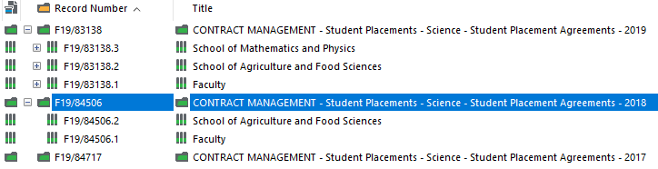

- Once you have created your file containers > drag and drop your documents from the network share drive, Outlook or other locations on top of the appropriate UQ Sub-File > select UQ Document as the record type and complete the profile form or just select OK to save if the title is correct. [Refer: D19/727043 and D19/727041]
- If an agreement is deemed Commercial-In-Confidence, access controls can be applied. [Refer: D19/644857] or contact Records Management and Advisory Services (details below).

Recommended document naming convention
- The title should summarise the contents so that it is not necessary to open the record to know what it is. Include a subject, topic, record type or action.
- Make the name unique wherever possible by including “when”, “who” or a unique identifier such as a Project ID.
- Be consistent – agree on a format for dates or names and stick to it.
For example: Overarching Student Placement Agreement - Non-clinical – 2019-02-15 – Airbus
Overarching Student Placement Agreement - Clinical – 2019-11-14 - Greencross Vets Silkstone
Continuing Placement Agreement - Mathematics and Physics Industry Project – 2019-11-14 - Aginic Holdings - SCIE3255

Use of Student Files
Individual agreements between students and partner organisations should be saved to the student’s file.
In addition, related information can be saved to student files. For example, copies of correspondence sent from InPlace or through CRM.
To automatically upload correspondence to a Student File, the minimum requirements are as follows:
- Send the finalised individual student agreement to recordsmanagement@uq.edu.au (RMAS Auto Upload in the address book).
- In the case of correspondence with the student you can blind copy (Bcc) to the above address in order to keep a copy on the student’s file.
- Use the Send to TRIM function within CRM.
Note: The above address is for automatic upload of documents and is not monitored for general enquiries.

Further information
- Visit:
  - the Records management systems section of the Systems Training Hub; this also provides access to multiple eLearning modules
  - F19/40817 (KNOW HOW - Education and Awareness - UQ Information Systems - Micro Focus Content Manager TRIM - How To Guide) on TRIM (link below)
Contact the Records Management and Advisory Services team at uqcentralrecords@uq.edu.au

CRISCO Provider 00258
Document Reference Number: D19/1546897

